Test Case: tc001_SPX_Dev5_Crear_Nueva_Linea_Requisicion_Spot_Tipo_Cobro_CC
Step 1 - Enter username and password and click to button Enter : Credentials Entered
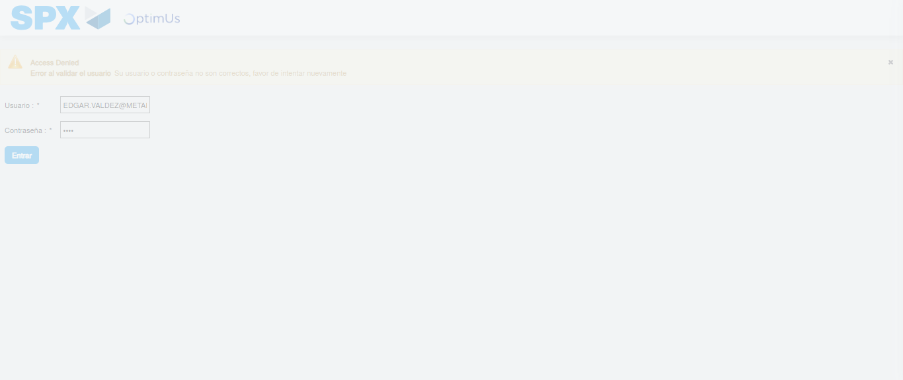Image file-name: QC_Testing-tc001_SPX_Dev5_Crear_Nueva_Linea_Requisicion_Spot_Tipo_Cobro_CC-1781313038205

Step 2 - Select to UEN and Access to Spot Buy Requisitions : UEN Correctly selected and Correct access
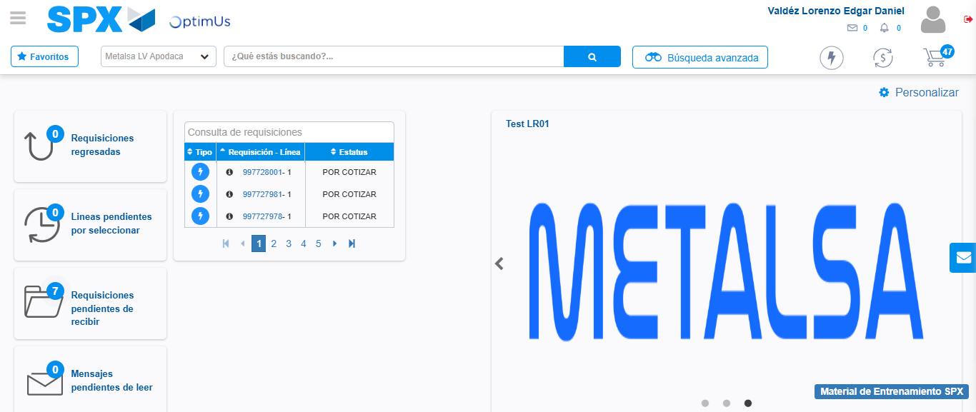Image file-name: QC_Testing-tc001_SPX_Dev5_Crear_Nueva_Linea_Requisicion_Spot_Tipo_Cobro_CC-1781313063115

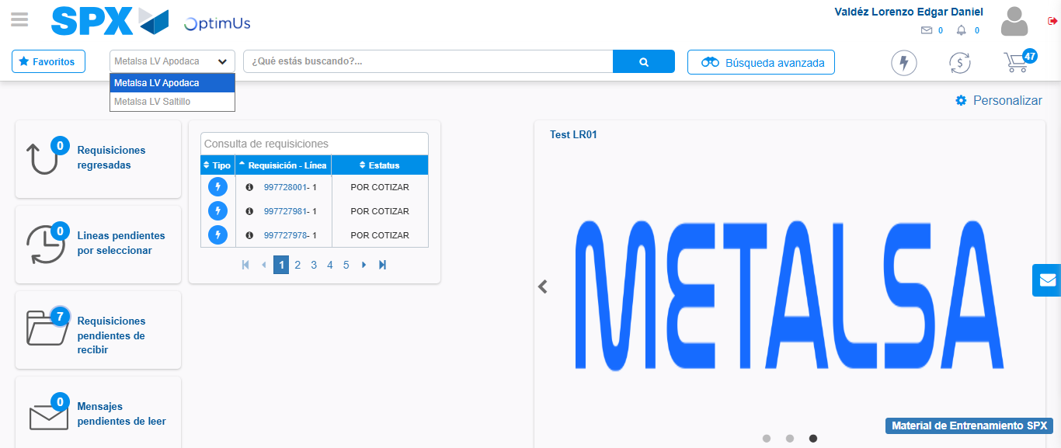Image file-name: QC_Testing-tc001_SPX_Dev5_Crear_Nueva_Linea_Requisicion_Spot_Tipo_Cobro_CC-1781313065711

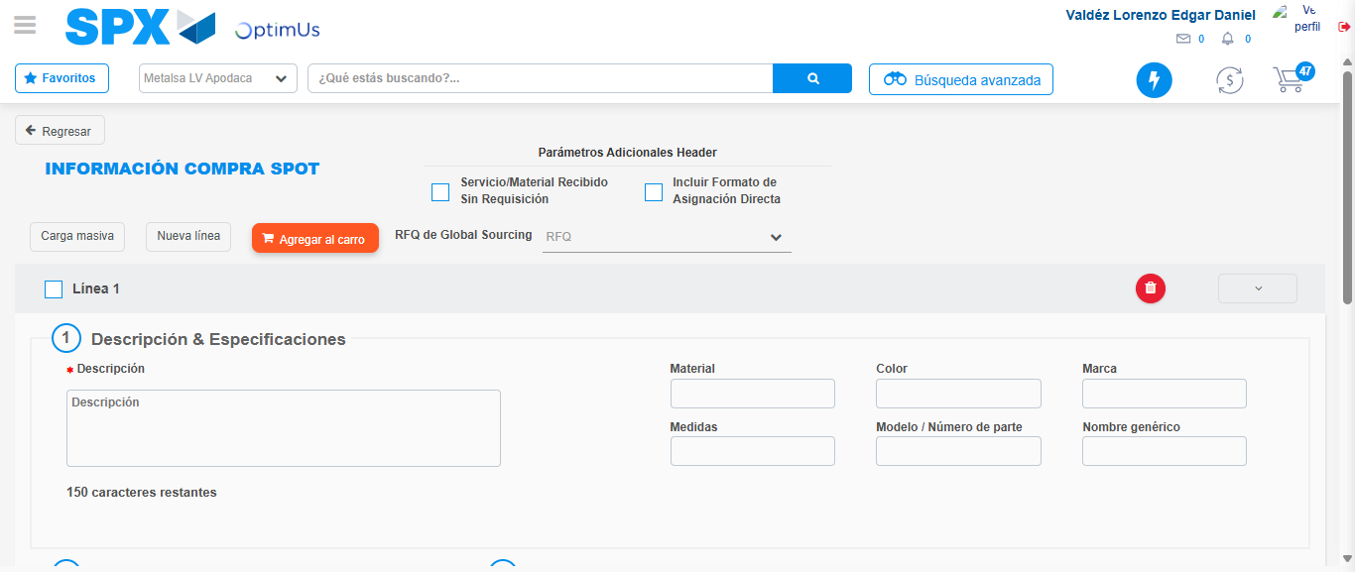Image file-name: QC_Testing-tc001_SPX_Dev5_Crear_Nueva_Linea_Requisicion_Spot_Tipo_Cobro_CC-1781313090792

Step 3 - Data Capture Spot Buy Requisition: Data captured correctly
Image file-name: QC_Testing-tc001_SPX_Dev5_Crear_Nueva_Linea_Requisicion_Spot_Tipo_Cobro_CC-1781313091047

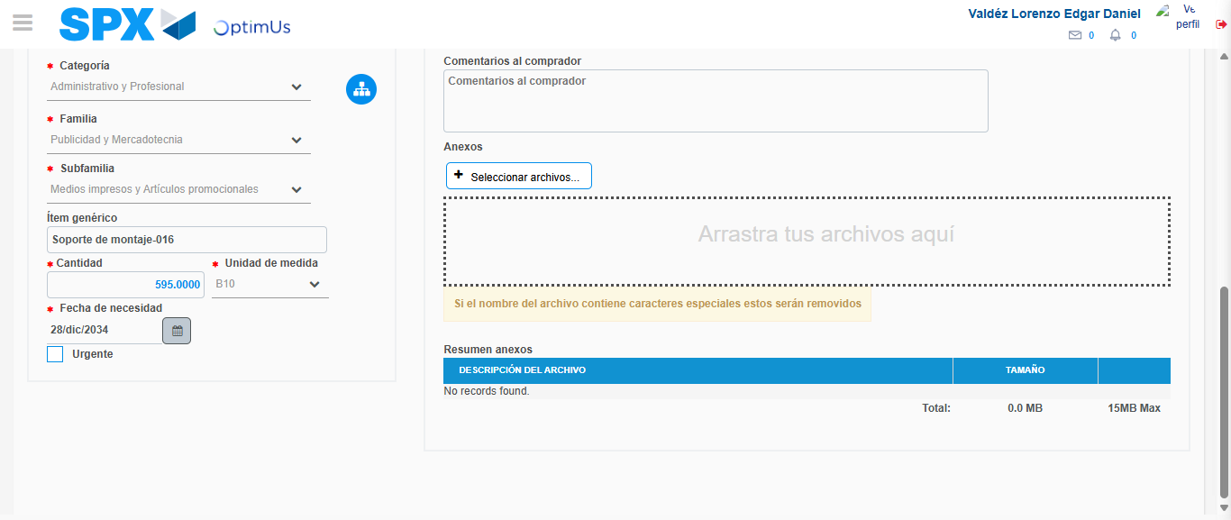Image file-name: QC_Testing-tc001_SPX_Dev5_Crear_Nueva_Linea_Requisicion_Spot_Tipo_Cobro_CC-1781313101912

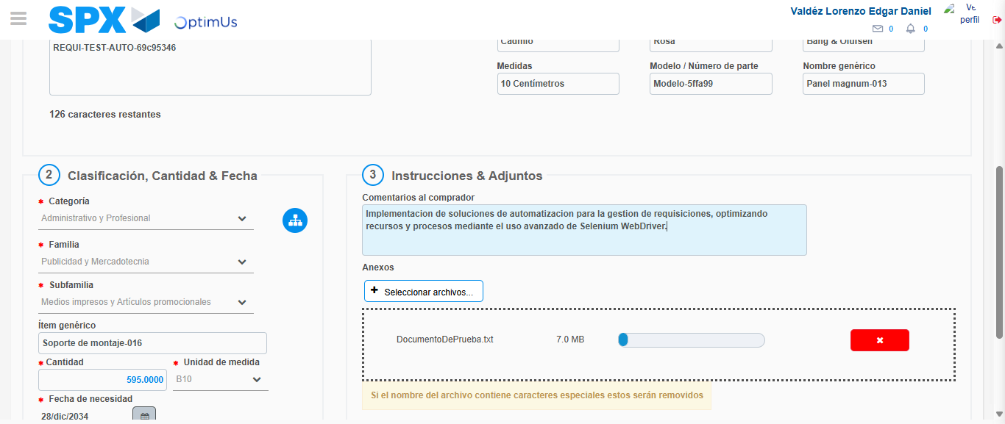Image file-name: QC_Testing-tc001_SPX_Dev5_Crear_Nueva_Linea_Requisicion_Spot_Tipo_Cobro_CC-1781313102681

Step 4 - Add new line and data capture second line: Line add correctly
Image file-name: QC_Testing-tc001_SPX_Dev5_Crear_Nueva_Linea_Requisicion_Spot_Tipo_Cobro_CC-1781313091047

Image file-name: QC_Testing-tc001_SPX_Dev5_Crear_Nueva_Linea_Requisicion_Spot_Tipo_Cobro_CC-1781313101912

Image file-name: QC_Testing-tc001_SPX_Dev5_Crear_Nueva_Linea_Requisicion_Spot_Tipo_Cobro_CC-1781313102681

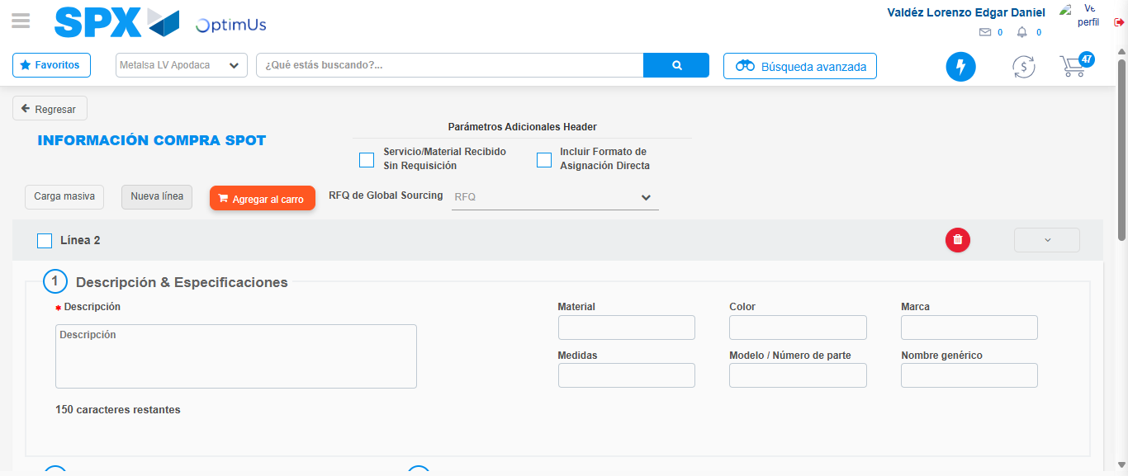Image file-name: QC_Testing-tc001_SPX_Dev5_Crear_Nueva_Linea_Requisicion_Spot_Tipo_Cobro_CC-1781313105005

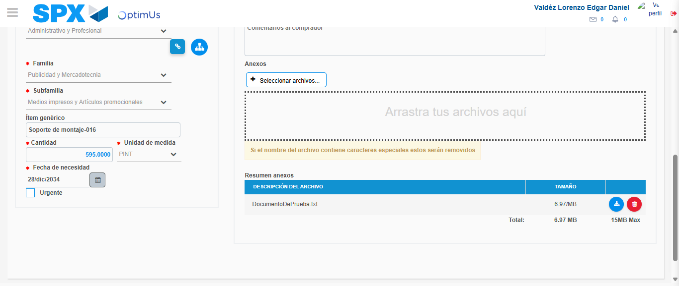Image file-name: QC_Testing-tc001_SPX_Dev5_Crear_Nueva_Linea_Requisicion_Spot_Tipo_Cobro_CC-1781313114847

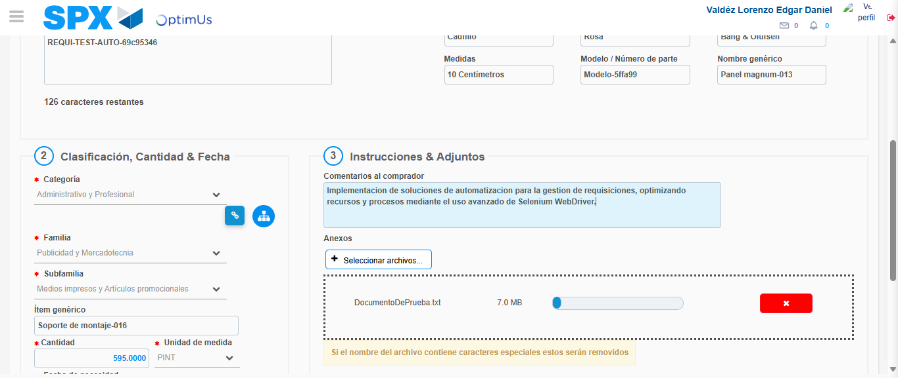Image file-name: QC_Testing-tc001_SPX_Dev5_Crear_Nueva_Linea_Requisicion_Spot_Tipo_Cobro_CC-1781313115627

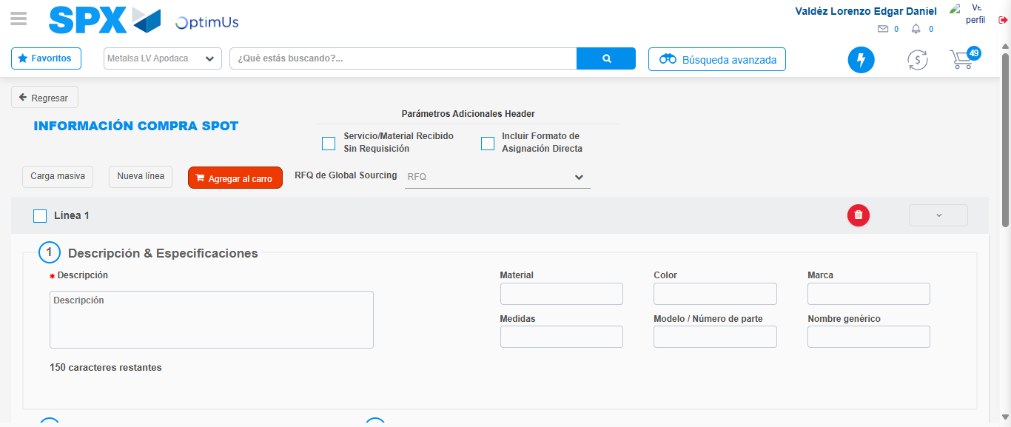Image file-name: QC_Testing-tc001_SPX_Dev5_Crear_Nueva_Linea_Requisicion_Spot_Tipo_Cobro_CC-1781313127935

Step 5 - Select to Requisition: Requisition Correctly selected
Image file-name: QC_Testing-tc001_SPX_Dev5_Crear_Nueva_Linea_Requisicion_Spot_Tipo_Cobro_CC-1781313128146

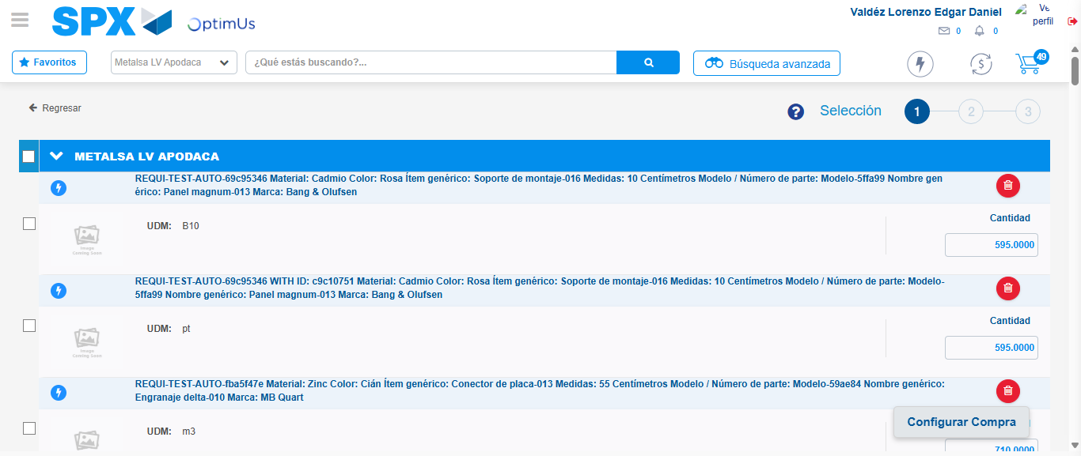Image file-name: QC_Testing-tc001_SPX_Dev5_Crear_Nueva_Linea_Requisicion_Spot_Tipo_Cobro_CC-1781313133155

Image file-name: QC_Testing-tc001_SPX_Dev5_Crear_Nueva_Linea_Requisicion_Spot_Tipo_Cobro_CC-1781313133373

Image file-name: QC_Testing-tc001_SPX_Dev5_Crear_Nueva_Linea_Requisicion_Spot_Tipo_Cobro_CC-1781313133572

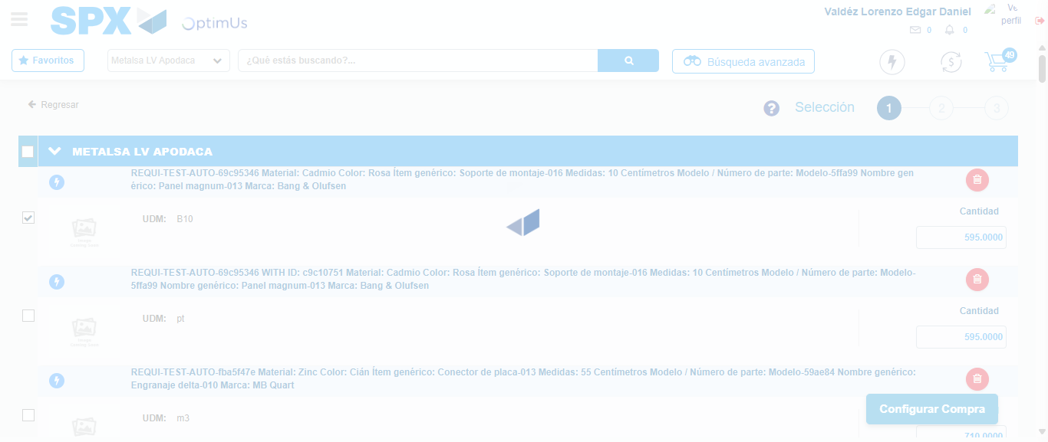Image file-name: QC_Testing-tc001_SPX_Dev5_Crear_Nueva_Linea_Requisicion_Spot_Tipo_Cobro_CC-1781313134419

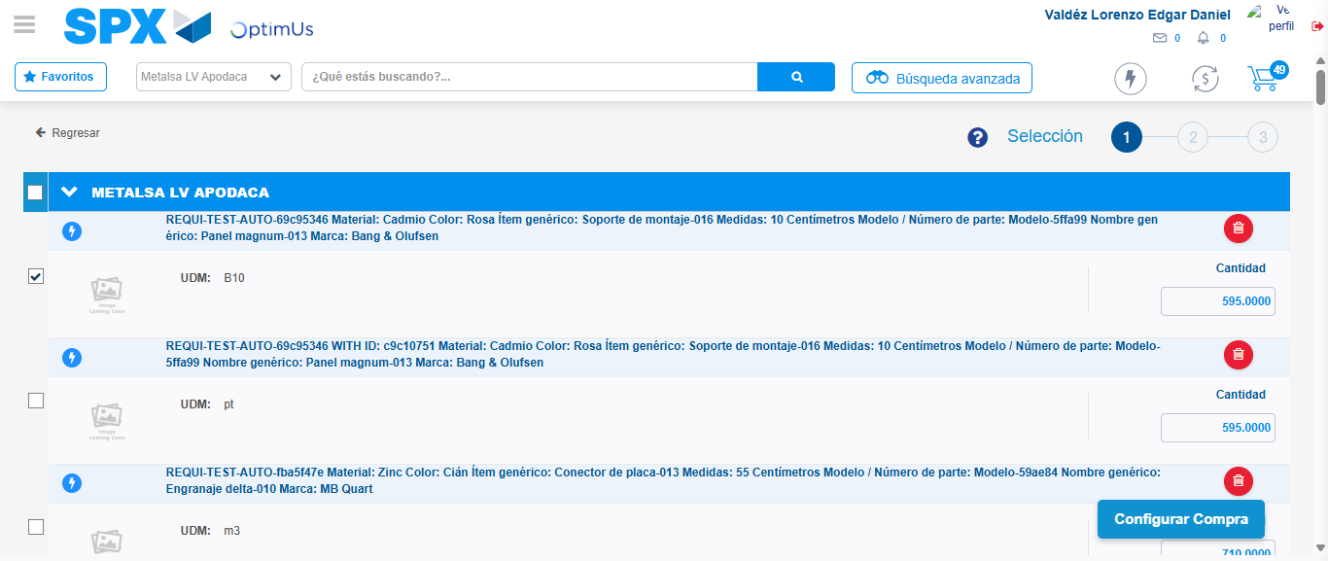Image file-name: QC_Testing-tc001_SPX_Dev5_Crear_Nueva_Linea_Requisicion_Spot_Tipo_Cobro_CC-1781313134600

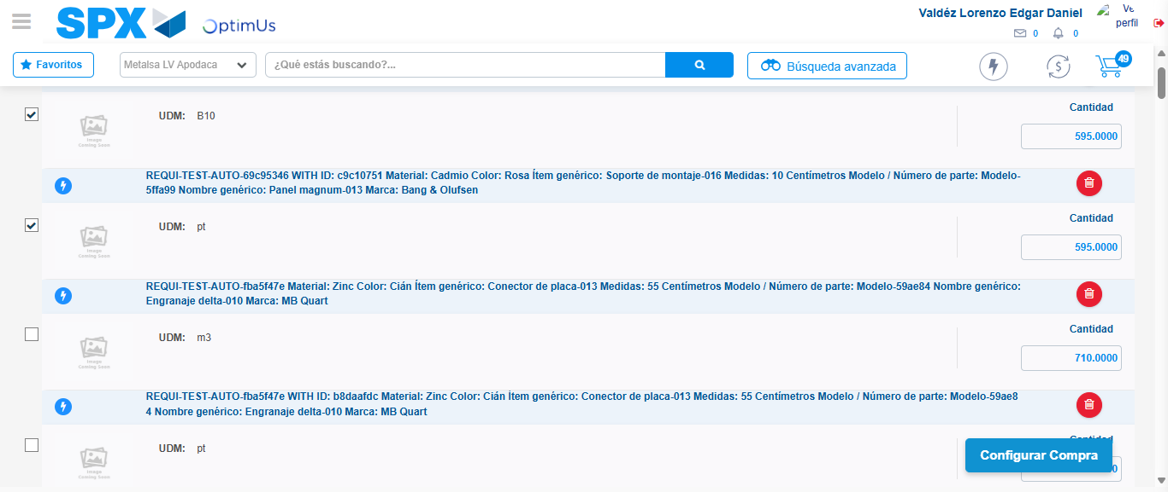Image file-name: QC_Testing-tc001_SPX_Dev5_Crear_Nueva_Linea_Requisicion_Spot_Tipo_Cobro_CC-1781313135494

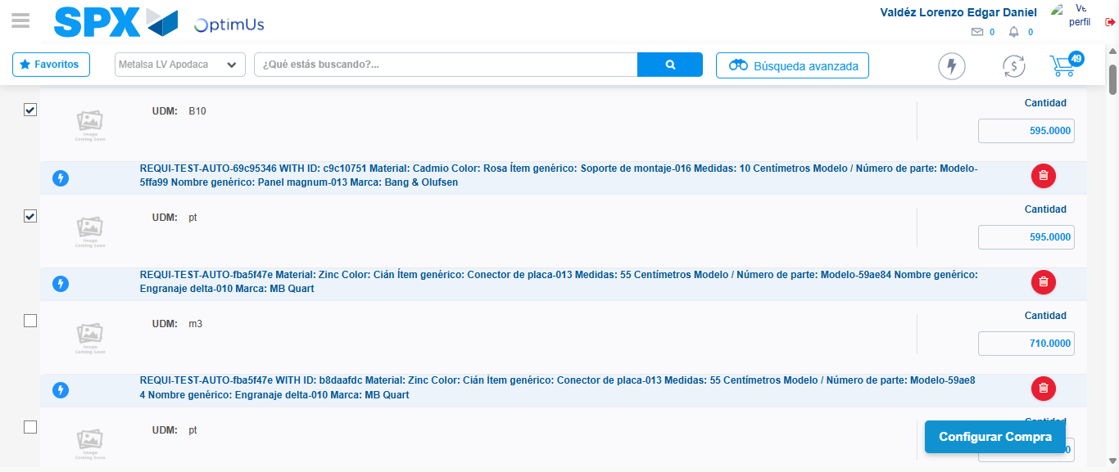Image file-name: QC_Testing-tc001_SPX_Dev5_Crear_Nueva_Linea_Requisicion_Spot_Tipo_Cobro_CC-1781313135727

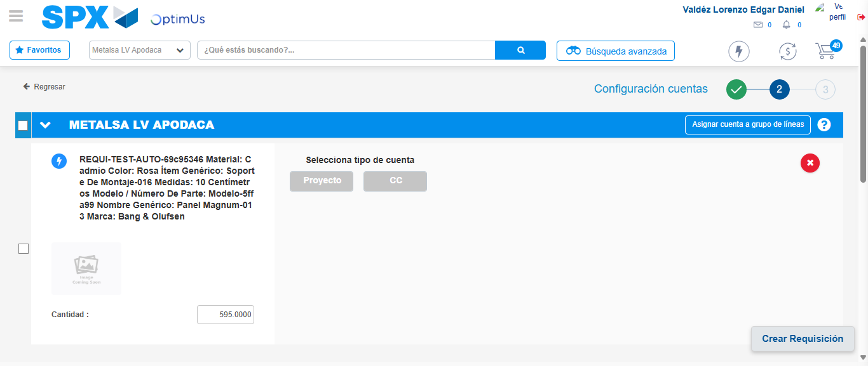Image file-name: QC_Testing-tc001_SPX_Dev5_Crear_Nueva_Linea_Requisicion_Spot_Tipo_Cobro_CC-1781313140424

Step 6 - Select Type Account For Requisition: Type Account Correctly selected
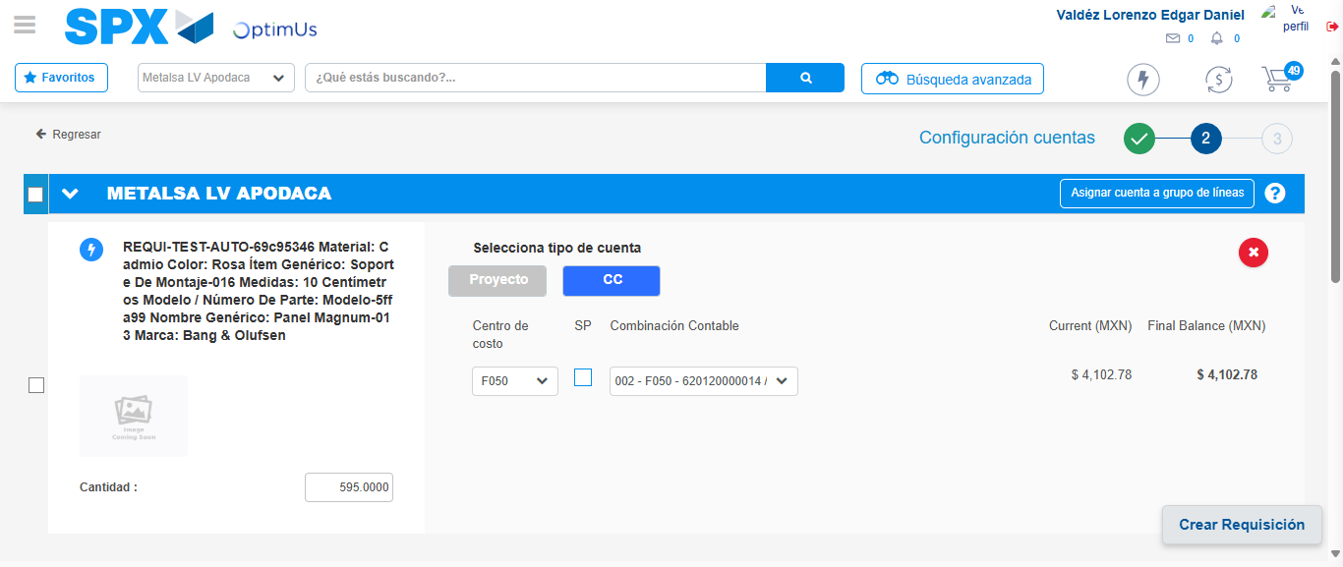Image file-name: QC_Testing-tc001_SPX_Dev5_Crear_Nueva_Linea_Requisicion_Spot_Tipo_Cobro_CC-1781313148515

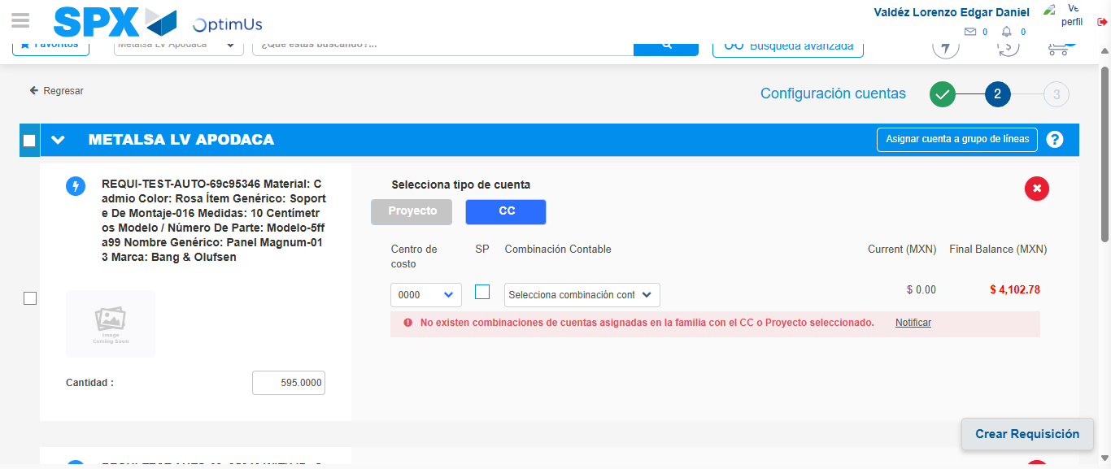Image file-name: QC_Testing-tc001_SPX_Dev5_Crear_Nueva_Linea_Requisicion_Spot_Tipo_Cobro_CC-1781313159517

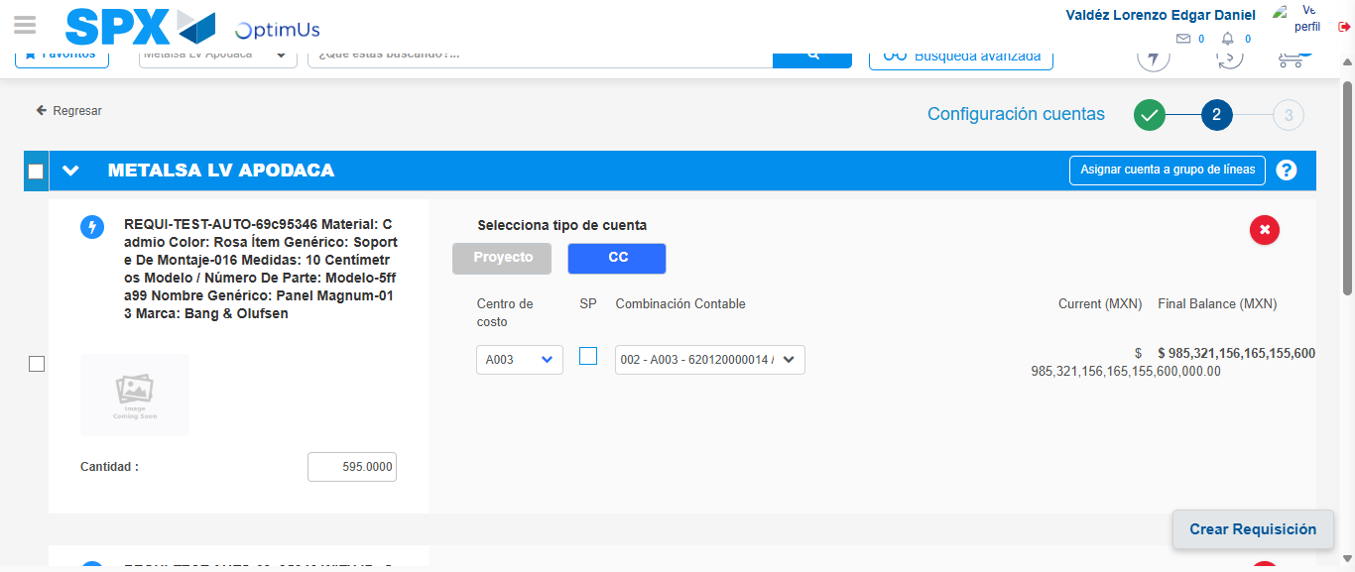Image file-name: QC_Testing-tc001_SPX_Dev5_Crear_Nueva_Linea_Requisicion_Spot_Tipo_Cobro_CC-1781313167942

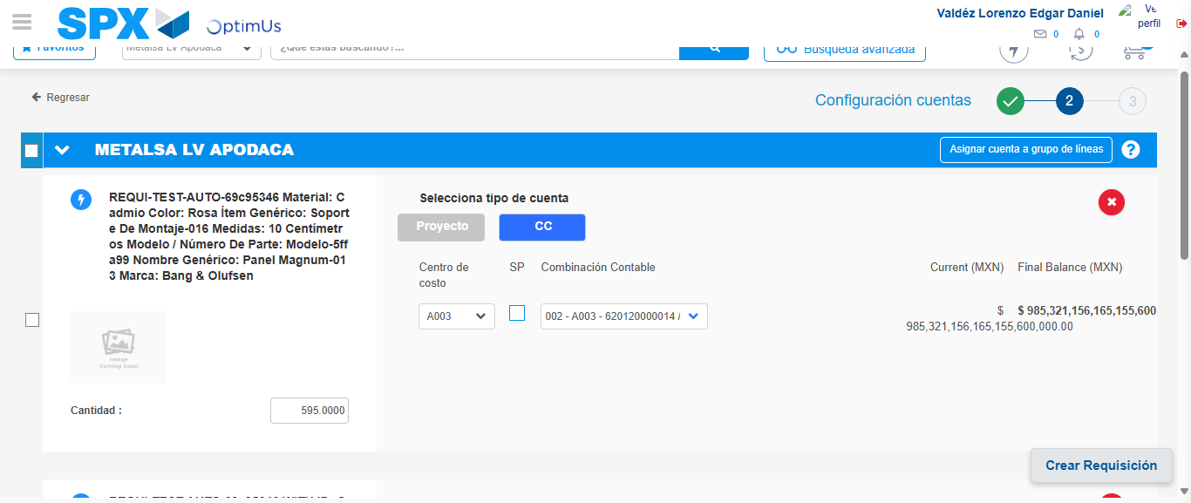Image file-name: QC_Testing-tc001_SPX_Dev5_Crear_Nueva_Linea_Requisicion_Spot_Tipo_Cobro_CC-1781313170567

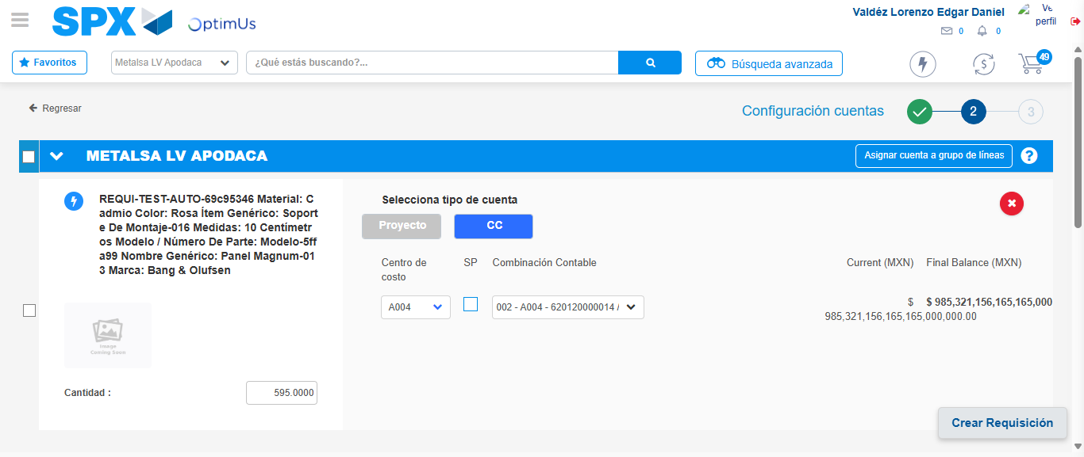Image file-name: QC_Testing-tc001_SPX_Dev5_Crear_Nueva_Linea_Requisicion_Spot_Tipo_Cobro_CC-1781313178757

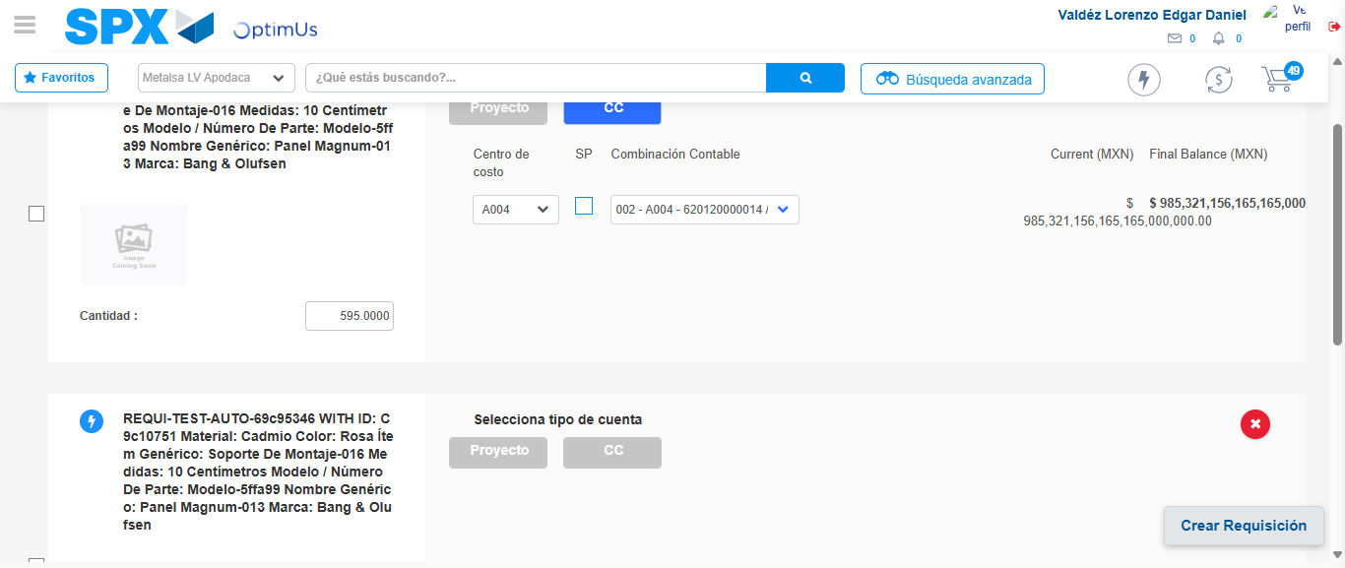Image file-name: QC_Testing-tc001_SPX_Dev5_Crear_Nueva_Linea_Requisicion_Spot_Tipo_Cobro_CC-1781313181371

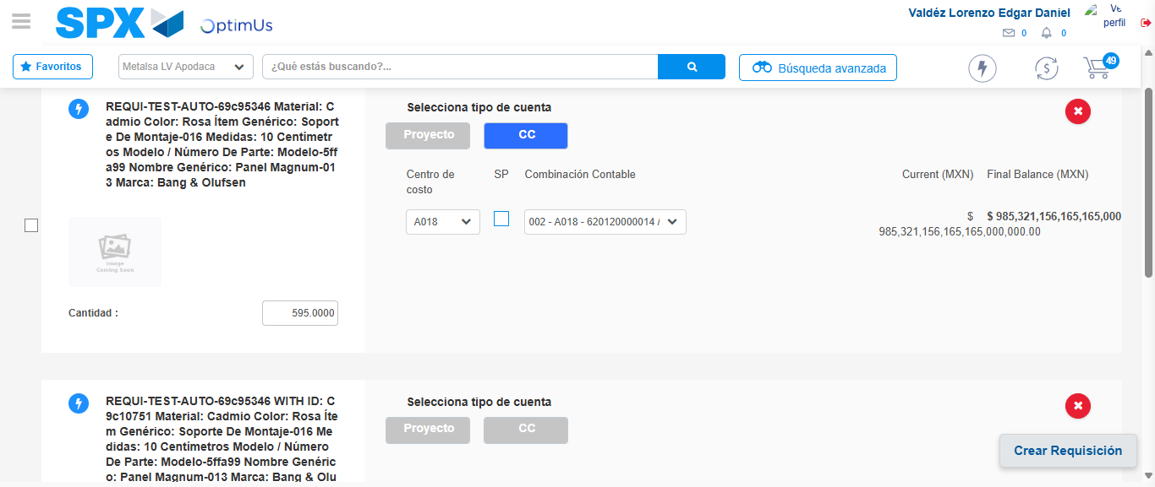Image file-name: QC_Testing-tc001_SPX_Dev5_Crear_Nueva_Linea_Requisicion_Spot_Tipo_Cobro_CC-1781313189063

Image file-name: QC_Testing-tc001_SPX_Dev5_Crear_Nueva_Linea_Requisicion_Spot_Tipo_Cobro_CC-1781313191763

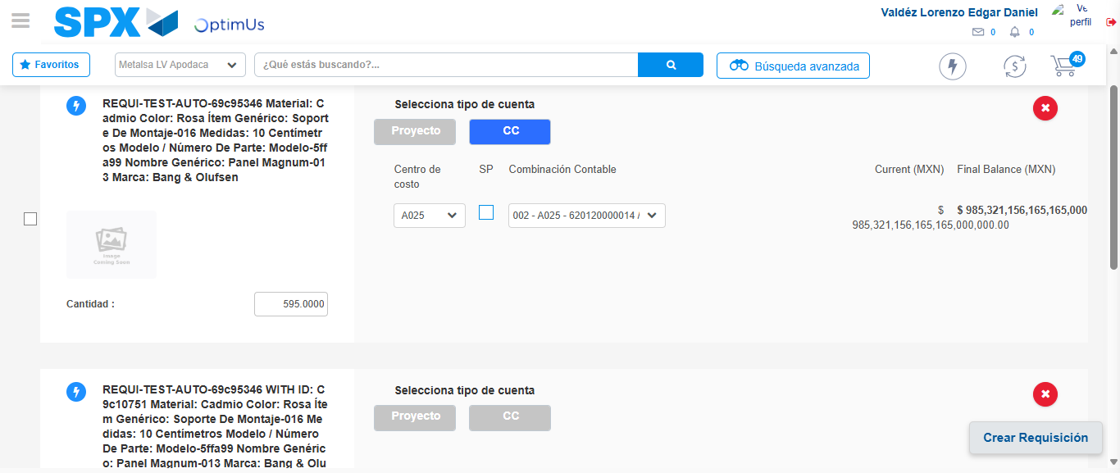Image file-name: QC_Testing-tc001_SPX_Dev5_Crear_Nueva_Linea_Requisicion_Spot_Tipo_Cobro_CC-1781313198994

Image file-name: QC_Testing-tc001_SPX_Dev5_Crear_Nueva_Linea_Requisicion_Spot_Tipo_Cobro_CC-1781313201600

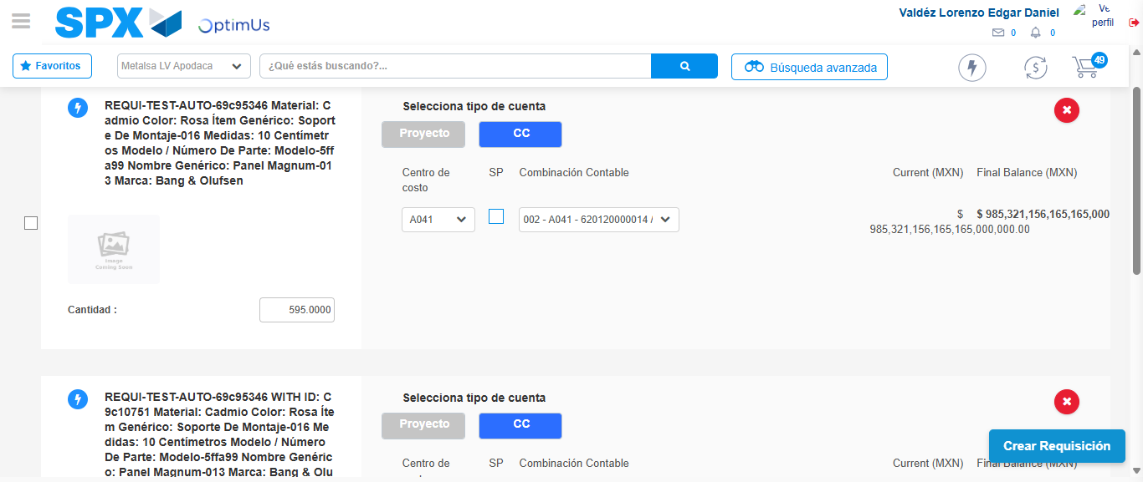Image file-name: QC_Testing-tc001_SPX_Dev5_Crear_Nueva_Linea_Requisicion_Spot_Tipo_Cobro_CC-1781313214624

Image file-name: QC_Testing-tc001_SPX_Dev5_Crear_Nueva_Linea_Requisicion_Spot_Tipo_Cobro_CC-1781313216927

Image file-name: QC_Testing-tc001_SPX_Dev5_Crear_Nueva_Linea_Requisicion_Spot_Tipo_Cobro_CC-1781313217152

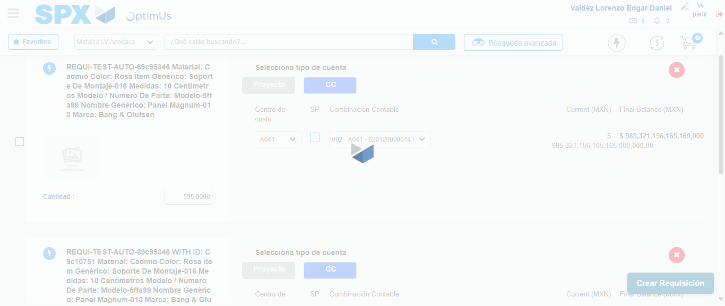Image file-name: QC_Testing-tc001_SPX_Dev5_Crear_Nueva_Linea_Requisicion_Spot_Tipo_Cobro_CC-1781313217586

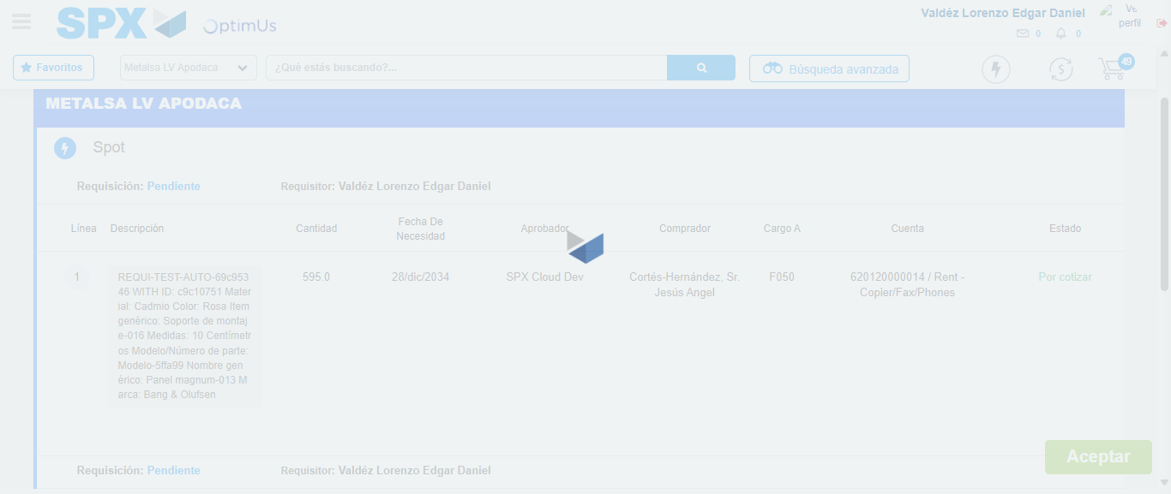Image file-name: QC_Testing-tc001_SPX_Dev5_Crear_Nueva_Linea_Requisicion_Spot_Tipo_Cobro_CC-1781313217840

Step 7 - Accept to Requisition: Requisition Accepted
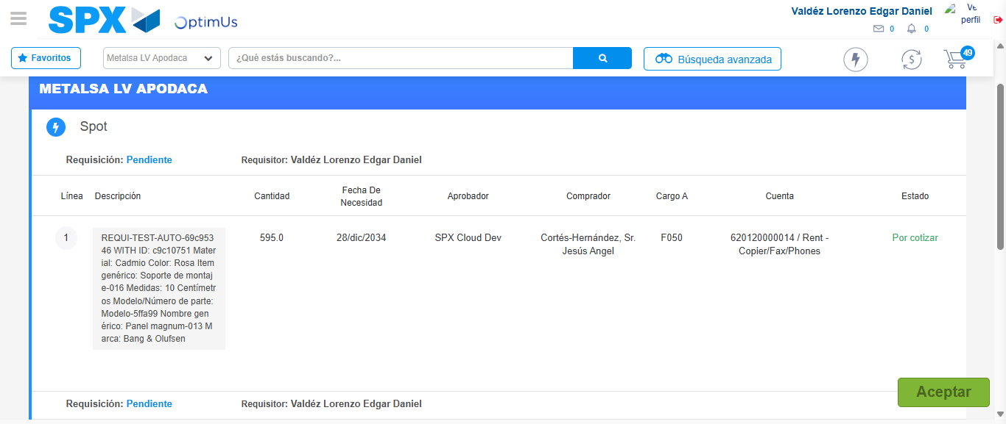Image file-name: QC_Testing-tc001_SPX_Dev5_Crear_Nueva_Linea_Requisicion_Spot_Tipo_Cobro_CC-1781313218577

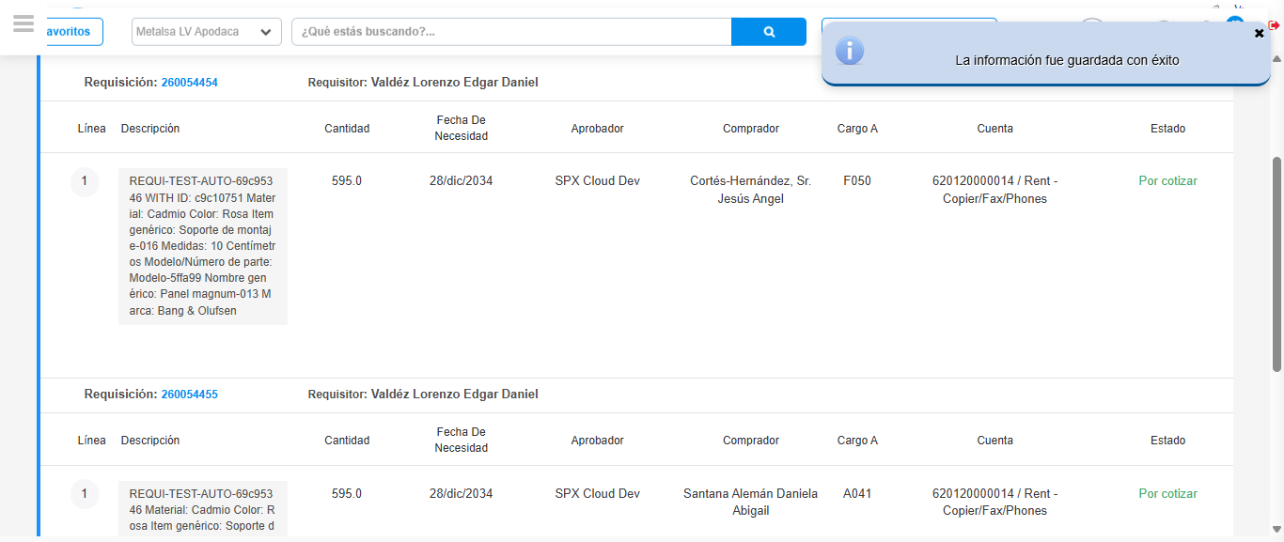Image file-name: QC_Testing-tc001_SPX_Dev5_Crear_Nueva_Linea_Requisicion_Spot_Tipo_Cobro_CC-1781313221083

Step 8 - Return to Main Page SPX : Return to Main Page SPX
Image file-name: QC_Testing-tc001_SPX_Dev5_Crear_Nueva_Linea_Requisicion_Spot_Tipo_Cobro_CC-1781313063115

Image file-name: QC_Testing-tc001_SPX_Dev5_Crear_Nueva_Linea_Requisicion_Spot_Tipo_Cobro_CC-1781313065711

Image file-name: QC_Testing-tc001_SPX_Dev5_Crear_Nueva_Linea_Requisicion_Spot_Tipo_Cobro_CC-1781313090792

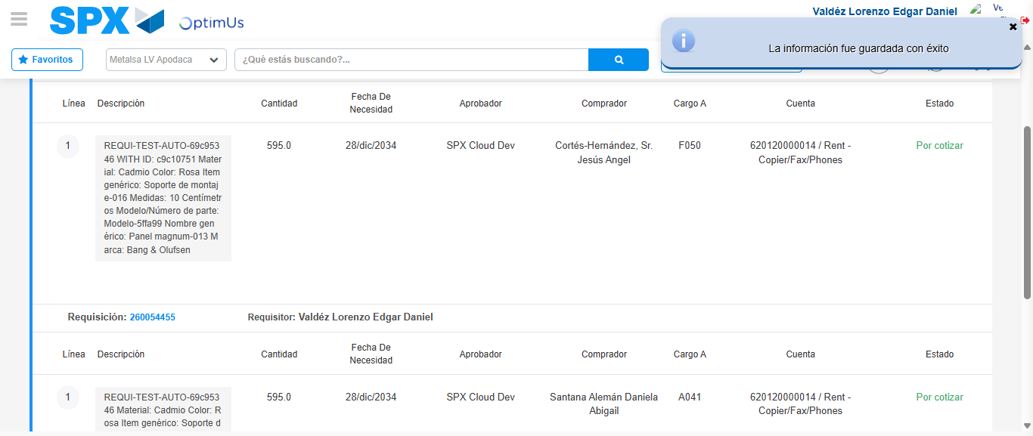Image file-name: QC_Testing-tc001_SPX_Dev5_Crear_Nueva_Linea_Requisicion_Spot_Tipo_Cobro_CC-1781313223345

Image file-name: QC_Testing-tc001_SPX_Dev5_Crear_Nueva_Linea_Requisicion_Spot_Tipo_Cobro_CC-1781313223510

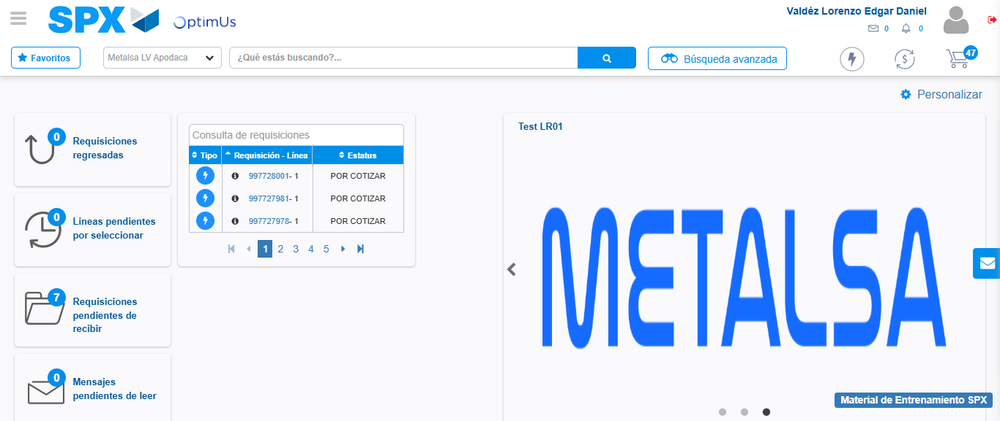Image file-name: QC_Testing-tc001_SPX_Dev5_Crear_Nueva_Linea_Requisicion_Spot_Tipo_Cobro_CC-1781313244625

Step 9 - Log Out : Log Out SPX
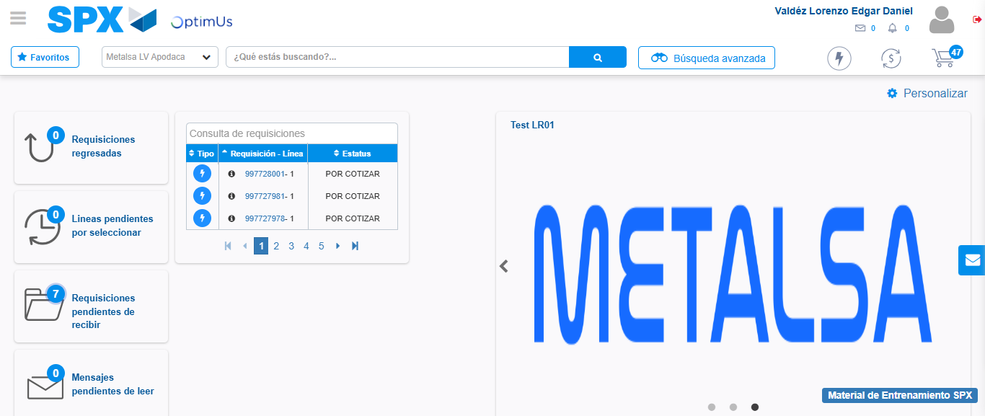Image file-name: QC_Testing-tc001_SPX_Dev5_Crear_Nueva_Linea_Requisicion_Spot_Tipo_Cobro_CC-1781313244889

